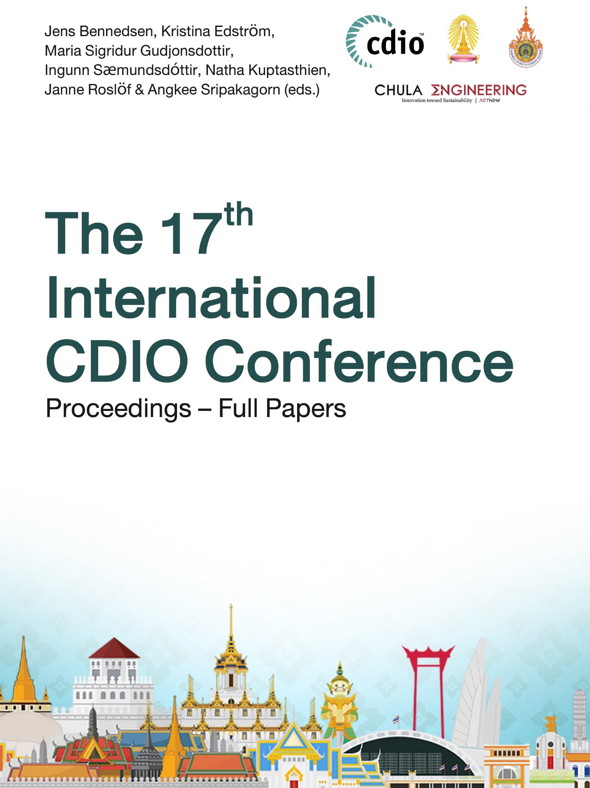
referencesWiek

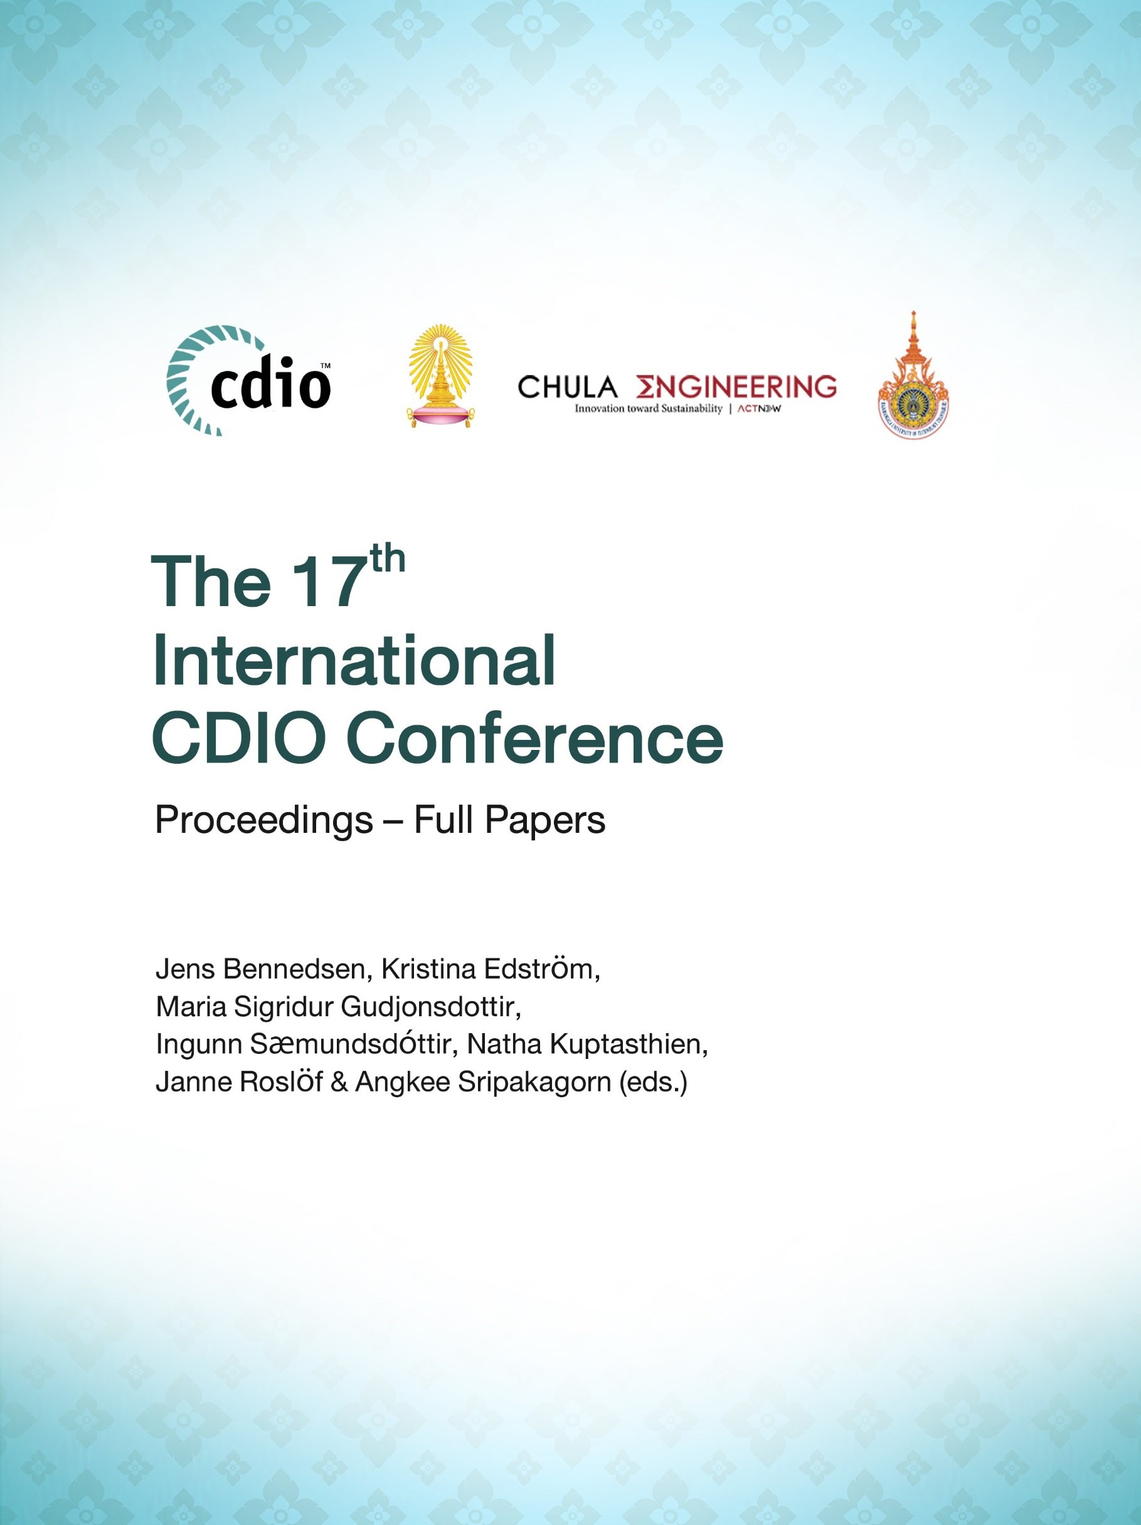

Table of Contents
Editorial 1 Conference Organization 3

Advances in CDIO
18 Development of Student Sustainability Awareness, Attitudes and Actions 14
Sayed Mohamad Soleimani, Abdullah Mughrabi, Maram Al Far and Martin Jaeger
32 CDIO. Can We Continue the Way We Are? 26
Aldert Kamp
63 Choosing the Right D for Design 44
Joseph Timothy Foley and Marcel Kyas
79 An Innovative Approach to Interdisciplinary Education through Domain Sector
Courses 52
Yaroslav Menshenin and Clement Fortin
104 Experiences from Applying the CDIO Standard for Sustainable Development in Institution-Wide Program Evaluation 62 Anders Rosén, Hélène Hermansson, Göran Finnveden and Kristina Edström
131 Student Engagement: A Proposed Optional Standard 74
Kuntinee Maneeratana and Danai Wangsaturaka

CDIO Implementation
- Assessment for Academic Learning during the COVID-19 Pandemic 84
Sanidda Tiewtoy and Natha Kuptasthien
- Using the Sustainable Development Goals (SDGs) in Automatic Control Courses 95
Svante Gunnarsson and Inger Erlander Klein
- Applying the CDIO Framework when Developing the ECIU University 106
Svante Gunnarsson and Maria Swartz
- Effects of Migrating Large-Scaled Project Groups to Online Development Teams 116
Daniel Einarson and Marijana Teljega
- On-Site and Online Combination for Student Exchange Program 127
Natha Kuptasthien, Sanidda Tiewtoy, Dong Joo Song and Dong Jin Kang
- Project-Based Learning Implementation - Collaboration between University and
Industry 137
Carmen Jaca, Marta Ormazabal, Mikel Arizmendi and Carmen Blanco

- The Implementing of CDIO Concept in the NKRAFA 147
Thapanat Buaphiban and Kiatkulchai Jitt-Aer
- A CDIO Competency Framework for VINH University's Teaching Faculty 157
Trần Thị Ngọc Yến, Trần Bá Tiến and Nguyễn Xuân Bình
- The Win-Win of Synchronizing Last Semester’s Computer Engineering Courses 168
Kamilla Klonowska, Fredrik Frisk and Daniel Einarson
- Sustainable Development in Chemical Engineering Curriculum: Review and
Moving Ahead 179
Sin-Moh Cheah
- Using Critique Techniques to Improve Programming Skill 192
Elynn Chee
- Evaluation of Spiral Curriculum for Chemical Engineering Using CDIO Framework 202
Katerina Yang, Sin-Moh Cheah and Siew Teng Phua
- CDIO Approach in Developing Solution Minded Learners 214
Handojo Djati Utomo and Geok Ling Soo-Ng
19 Towards an Intuitive and Objective Assessment for Project-Based Modules 224
Chew Lin Chia
- A Report of Cross-Course-Typed PBL and Students’ Self-Assessment 235
Kuniaki Yajima, Koji Kawasaki, Yoshikatsu Kubota, Shinji Chiba, Jun Suzuki and Hisashi Takeshima
- Designing Blended-Type Integrated Learning Experience Using Core Principles of Learning 246 Sin-Moh Cheah
- Transfer of Self-Directed Learning Competency 259
Yunyi Wong, Poh Hui Chua and Sin-Moh Cheah
- Enhancing Workplace Learning Through Structured Internship 272
Kallen Chong, Poh Hock Neo, Sock Hiang Sing, Thachinamoorthi Krishnan and Keng Wah Choo
- Evidence-Based Reflective Practice for Engineering Repeat Students in Flipped Learning 282 Ying-Wei Leong
31 Assessing Students' Professional Criticism Skills – A Mathematics Course Case 293
Jens Bennedsen
- Developing and Assessing Teamwork with Enhanced Team-Based Learning
Approach 303
Geok Ling Soo-Ng and Nengfu Tao
- CDIO Approach for Development of Temperature Rise Monitoring System 313
Nengfu Tao, Xiaodong Li and Jinping Lu
- Projects Evaluation in IT Engineering Curriculum of Tra Vinh University 324
Nhiem Ba Nguyen, Nam Thi Phuong Phan, Quoc Khac Nguyen, Mien Phuoc Doan, Mai Thi Truc Pham, Tu Minh Le and Duy Khanh Nguyen
- Integrated CAD and Reverse Engineering to Enhance Conception and Design 336
Ahmed Tamkin Butt and Petros Siegkas

41 Maximising Student's Learning through Learning Analytics 351
Mark Wan and Siew Kee Chong
45 Work-Based Learning Model to Develop Self-Directed Learners in Optometry
Education 365
Sumasri Kallakuri, Li Li Tan and Adrian Yeo Chao Chuang
- From Lab-Based to Home-Based: Application of Blended Learning 377
Siew Ling Tan and Eunice Goh
- CDIO Approach on O2O International Learning Model through SDG Course 388
Alicia Amelia Elizabeth Sinsuw, Tsung-Hsien Chen, Chen-Yeon Chu, Chen-Hua Hsueh and Ben-Ray Jai
- A New Approach to Engineering Education at Tsuruoka Kosen 400 Ryo Shomura, Hiroyuki Arafune, Takashi Morinaga, Sou Takahashi, Ryo Satoh, Shinichiro Hoshina, Mitsuaki Yamada, Yuko Usuba and Koichi Watanabe
61 Implementation of E-Practical Lessons during Pandemic 406
Boon-Seng Chew, Boon-Chor Seow, Chee-Seng Tan, Hwang-Keng Leck, Chow-Leong Chia and Ser-Khoon Toh
64 Adapting CDIO Framework to Cultivate Self-Directed Learning during COVID-19
COVID-19 Pandemic 419
Toh Ser Khoon, Chia Chow Leong, Hua Joo Tan and Safura Anwar
- Continuous Assessment with Flipped Learning and Automated Assessment 433
Nicolás Serrano Bárcena, Carmen Blanco, Kevin Calderón, Iñigo Gutierrez and María Serrano
- Teaching Reform of Combining Innovation Ability Training with Engineering
Education 444
Zhiqiang Wang, Hua Shen, Long Liu, Minghao Ning and Yong Yang
- Data Analytics of Students Continuous Assessment Activity Data 455
Kevin Calderón, María Serrano, Nicolás Serrano Bárcena and Carmen Blanco
74 Introduction to Industrial Design and Product Case Studies 465
Petros Siegkas
- C Programming Language Teaching Based on CDIO 473
Shuhong Wang, Jiandong Liu, Yiqun Dong and Qingxuan Wei
- Navigating Uncharted Waters: A One-Year German-Finnish Faculty Exchange 484
Patric Granholm, Juha Kontio, Andreas Baumgart and Martina Schulze
- Designing a New Industry-Related Specialization in Electronic Systems Design 495
Dominik Osinski, Ashkan Moradi and Dag Roar Hjelme
87 Implementation and Evaluation of a New PBL Assessment Mechanism 505
Mohamad Farhat, Michel Nahas and Hassan Salti
- Flipped Learning Analytics Real-Time (FLARET) Framework for Assessing Student Learning 514 Thian-Siong Choo
- Developing Curricula by Black Box Method 526
Patric Granholm, Kari Haajanen, Mari Ketola and Anne Norström

- Improving Students Engagement with Active Learning in Engineering Optimisation Lectures 535 Gauti Asbjörnsson and Kanishk Bhadani
96 Intended Learning Outcomes of Seven Finnish B.Sc. in IT Programs 546
Janne Roslöf
98 Development of Engineering Workspaces for Hands-On and Project-Based
Learning 559
Yuliya Yu. Petrova, Ekaterina V. Sevast’yanova, Valeria A. Bezuevskaya and Ekaterina V. Kukhtenko
- CDIO Approach to Write Reference Models for Training Decision Skills 566
Thordur Vikingur Fridgeirsson, Haraldur Audunsson and Asrun Matthiasdottir
- Online Teaching Modes from the Perspective of Constructivism 576
Dan Mu, Hong Li and Ping Song
105 Implementing EduScrum Methodology in Online Project-Based Learning 583
Andrei Zapevalov, Dmitrii Kuzin, Anton Osipov, Pavel Grishmanovskiy and Larisa Zapevalova
111 Impact Analysis of Academic Reforms for CDIO Implementation: Case Study 592
S. J. Thiruvengadam, Baskar Subramanian, S. Saravana Perumaal, D. Anitha and Jeyamala Chandrasekaran
125 Adaptive and Flexible Online Learning during COVID-19 Lockdown 606
Soumya Kanti Manna, Ghazal Sheikholeslami, Angela Richmond-Fuller, Rihana Ishaq and Anne Nortcliffe

Engineering Education Research
13 Students’ Views of Self-Regulated Learning Strategies in a Blended Module 618
Sharon Yap
- Oral Group Examination Method to Evaluate Collaborative and Individual Learning 630
Karin Stenderup and Sanne Sandberg Overby
- Building Student Agency through Online Formative Quizzes 645
Louise Pick and Jonathan Cole
37 Utilizing Gamification In Mathematics Courses for Engineers to Promote Learning 655
Tamar Margalit, Lior Rosenzweig, Yonutz Stanchescu, Mika Gabel
46 Students’ Perceptions of Multicultural Group Work in International Engineering Classroom 668 Cui Ping, Ad Kleingeld, Sonja Rispens and Ruurd Taconis
- Gauging the Impact of CDIO and Momentum for Further Change 680
Louise Pick, Charlie McCartan, Kathryn Fee and Paul Hermon
- Students’ Readiness for Online Learning System in NIT 691
Namita Maharjan, Nayani Daranagama, Yoshihiro Ominato, Michiaki Omori, Shozo Urabe, Noboru Fukuda, Katsumi Ichimura and Yasuko Tsuchida

67 Cultivating Higher-Order Thinking Skills in English-as-a-Foreign-Language Technical Reading Instruction 702 Huey-nah Cindy Chou, Bing Jean Lee and Ben-Ray Jai
109 Design Exercise Strategy for Locus of Control and Self-Efficacy 712
Geza Fischl and Bengt Erlandsson
132 From Digitalized Education to COVID-19 Restricted Education: Challenges and Differences 722 Jerker Björkqvist and Tommy Hämäläinen
- Basic Need Frustration in Motivational Redesign of Engineering Courses 731
Gunter Bombaerts
- Flexible Tactics to Face COVID-19 and Social Outbreak in Chile 741
Rodrigo Pascual, Nicolás Bravo and Catalina Quiñones

A CDIO COMPETENCY FRAMEWORK FOR VINH UNIVERSITY'S TEACHING FACULTY

Trần Thị Ngọc Yến, Trần Bá Tiến, Nguyễn Xuân Bình

Department of Foreign Languages, Vinh University

ABSTRACT

Among factors that a university can control, teaching faculty plays the most crucial role (Hammond, Berry & Thoreson, 2010). This may explain why professional teachers at higher education institutes are generally required to possess essential competencies for the benefits of students. While many educators have agreed on the distinctive nature of higher education as compared to K12 levels, there seems to be no consensus on what competencies are the most fundamental. This paper in the first place argues for the necessity to formulate a lecturer competency framework for the teaching faculty at Vinh University, which has recently launched its newly designed CDIO curricula. The university has undergone a significant transformation since it joined the CDIO Initiative in 2005, thus being determined to reset its policy on requisite attributes for the lecturers. The paper also discusses the elements of competency, advantages of lecturer competency frameworks, and principles of formulating lecturer competency frameworks. In addition to that, reviews of teacher competency frameworks currently used by schools and universities around the world are provided. Finally, the paper describes the components included in the proposed framework together with explanations for the inclusion of those competencies.

KEYWORDS

faculty competence, teaching competence, CDIO competencies, CDIO competency framework, Standards: 9, 10

INTRODUCTION

Teacher competence is an essential factor in the education process (Tanguihan, 2016). A teacher has to perform various roles and thus is required to own specific skills, knowledge and attitudes in order to facilitate student learning. Previous studies have shown that of all the factors that a school can control, teaching faculty has the most significant impact on learner success (Sanders & Rivers, 1996; Izumi & Evers, 2002; Babu & Mendro, 2003; Leong, Singh & Sale, 2016). Several scholars assert that teachers who own standardized teaching certifications and attend professional training courses more frequently tend to produce better learning results (Hammond, Berry & Thoreson, 2010). Along similar lines, Gee (2018) found a positive correlation between teacher competence and student satisfaction.

An educational institution may require its teaching faculty to have certain qualifications and competencies depending on the economic, social and political context as well as its

educational needs. Although requirements may vary, they should be formulated in such a way that they would contribute to the teacher development process and facilitate the building of a strong and high-quality teaching community. Ministries of education in different countries have developed national teacher competency frameworks, which are commonly used as a compass to direct teachers' professional development and to assist them in their job performance.

Since it joined the CDIO Initiative, Vinh University has faced new challenges in innovating curricula and teaching methods. The implementation of the newly designed CDIO-based curricula has urged our lecturers to develop their personal and interpersonal skills, product, process, and system building skills as well as instructional skills (Đinh, Thái & Nguyễn, 2016). Although the university has issued institutional personnel regulation that points out several requirements for the lecturers, those statements are too generic and thus can barely be used to assist any stakeholders. A lecturer competency framework should, therefore, be established in order to provide the teaching faculty with a guideline for professional development throughout their careers. This type of document would also offer the administrators a useful reference for the process of recruiting, training, and evaluating the university's personnel.

LITERATURE REVIEW

Teacher Competence

The term teacher competence has been defined by various scholars. According to the European Commission (2003), teacher competence is a ''complex combination of knowledge, skills, understanding, values and attitudes, leading to effective action in situation''. For Houston (1985), teacher competence means skills and knowledge that a student must demonstrate upon completion of a teacher education program. Other researchers believe that teacher competence refers to skills and knowledge that teachers need in order to be successful in their career (Jackson, 1990; Spencer & Spencer, 1993; Boulter et al., 2003). This concept has also been defined as the combination of knowledge, skills and behaviors used for improving teaching quality or for performing an educational task (Tompea, 2011).

Past research has identified specific competencies that a teacher needs to gain in order to be qualified, including intellectual ability (Krauss et al., 2008), management skills, interpersonal skills (Hong et al., 2008; EU), proper contact with the audience (Huntley, 2003), problem solving skills and assessment methods (Peklaj, 2015), research and reflection skills (European Commission, 2013), critical thinking (Mac Laughlin & Talbert, 2001), the ability to create new knowledge (Cochran-Smith & Lytle, 2009) and the ability to adapt the curriculum to meet the learner's needs (Hatano & Oura, 2003, Vogt & Rogalla, 2009). In this study, we define teacher competence as the combination of knowledge, skills and attitudes to successfully perform teaching tasks in the contemporary educational context.

Developing a Framework of Teacher Competences

Teacher competency frameworks are valuable to almost all stakeholders of an educational system. The list of teacher competencies allows the stakeholders to be assured that all teachers have attained minimum standards and might serve as the basis for institutional or national recognition of the quality of teaching. The parameters in those frameworks can be of great use in recruitment, human management, evaluation and training processes. Without this set of teacher standards, these processes may be intuitive and inconsistent.

A few educators have attempted to formulate teacher competency frameworks. Selvi (2007), for instance, proposes that a teacher competency framework should comprise such components as technical competence, research competence, curriculum design and development competence, technology competence, communication competence and environment competence. More recently, Wing Institute (2020) has reported that the four most agreed aspects of teacher competency are teaching competence, classroom management competence, formative assessment competence, and interpersonal competence. However, Peklaj (2015) advocates a three-dimension framework that organizes teacher competencies into three groups: teacher competencies for promoting cognitive processes, teacher competencies for promoting affective-motivational processes, and teacher competencies for promoting social processes in students. Along similar lines, Vijay (2013)'s framework consists of three categories of competencies (teaching competence, organization competence and assessment competence).

Previous studies have discussed key features of a teacher competency framework. The European Commission (2013) contend that such parameters should be grounded in the culture of the country; be based upon a negotiated consensus about the purpose of teaching and about what constitutes successful teaching and learning; be based on the university's educational philosophy; accommodate all the dimensions of teachers’ professional work, in an integrated way; be based on the understanding that teaching involves a cycle of self-evaluation and improvement; be consistent with (but not limited by) the desired learner outcomes (e.g. in national curriculum guidelines); and have the key attributes of stability, durability and flexibility. Likewise, the Australian Ministerial Council on Education, Employment Training and Youth Affairs (2003) lists eight principles for developing a national teacher competency framework as follows: acknowledge the link between quality teaching and improved student learning outcomes; ensure consistency and enable recognition of quality teaching; reflect authentic and extensive knowledge about teaching and learning; encourage teachers to aspire to a higher level of performance; have regard for the future but are grounded in current effective professional practice; reflect the theoretical knowledge of specific content and pedagogy and the practical application of that knowledge to improve student learning; are outcomes–based to ensure strong links between standards for teaching, their evaluation and professional learning; reflect teachers’ professional experience and growth on a continuum from undergraduate preparation to professional leadership; and, promote, support, recognise and reward quality teaching in the full range of social and cultural contexts in which teaching occurs.

Teacher Competency Frameworks around the World

Many countries have declared their ways of defining teacher competences through either a simple linear or a multi-dimensional framework. These approaches to teacher competency framework development range from a light touch description such as government decrees on university qualifications (Finland), guidelines for broad outcomes expected of a teacher education curricula (Croatia), legislation describing teacher competences and skills that teacher education curricula must meet (Denmark) to complex description such as detailed lists of competences broken down into skills, knowledge, attitudes or values, together with indicators or can-do statements (Netherlands, Belgium, Scotland). Many of these frameworks are distinguished by school level and expertise level too (Australia, New Zealand)

A scrutiny into competency frameworks used in different countries has shown that although many countries have a national competency framework for K12 teachers. For example, the Western Australia's framework outlines competency standards for effective teaching across three broad phases of teacher's work and is based on a construct of five dimensions of

teaching (facilitating student learning, assessing and reporting student learning outcomes, engaging professional learning, participating in curriculum policy and other program initiatives in an outcomes-focused environment, forming partnerships with the school community). The Southeast Asia Teachers Competency Framework (The 11 Southeast Asia countries, 2018), which was endorsed by the SEAMEO High Officials Meeting in 2017 and later adopted by the Council of Ministers of Education from 11 countries in the region, consists of four essential competencies (knowing and understanding what to teach, helping students learn, engaging the community, and becoming a better teacher everyday) and twelve general competencies teachers must possess.

The currently available competency frameworks for university lecturers, however, are institutional rather than national. These frameworks were developed by universities to be used by their own stakeholders and thus merely share a common structure. For Vrije University of Amsterdam, the teaching faculty of this university is expected to possess five core competencies, namely didactic flexibility, social flexibility, developing teaching, cooperation and conscious lectureship. Meanwhile, Algonquin College (2013) established a competency framework for professors of the 21st century across three expertise levels (0-2 years' teaching, 2-7 years' teaching and 7+ years' teaching). As per this set of standards, a professor should attain seven competences (modeling professional practice within the discipline of teaching, creating engaging learning environments for individuals and groups that support academic and personal growth, using a variety of teaching/learning strategies, evaluating learning using a variety of valid and reliable tools and techniques, working independently and with others to develop and/or adapt learning materials, using technology to enhance productivity and helps students learn, designing and developing effective curriculum to support student success).

CDIO LECTURER COMPETENCE

The CDIO Standards 9 and 10 emphasize the importance of enhancing lecturer competence in personal and interpersonal skills, product, process and system building skills, providing integrated learning experiences, using active and experiential learning methods and assessing student learning. In the light of these standards, CDIO advocates have confirmed the necessity for lecturers to possess these competencies. For instance, Malmqvist, Gunnarsson and Eigild (2008) propose a list of situations in which CDIO lecturers have to possess professional skills so as to help students obtain those skills. The researchers found that the faculties members in their study agreed that proficiency in professional skills, and the skills to teach project-based courses and relate their research to the industrial context are essential for their work. Along similar lines, Crawley (2014) asserts that since lecturers have to teach personal and interpersonal skills, product, process and system building skills, they should be assisted to obtain those skills.

Although the importance of CDIO skills for lecturers has been emphasized, research in developing frameworks for CDIO lecturer competency is still in its infancy. Among the published works related to this topic, Leong, Singh and Sale (2016)'s is probably one of the most influential studies. These authors mentioned the Lecturer Competency Framework developed by 5 Singapore Polytechnics and the professional development programs in Singapore Polytechnic. The framework contains 11 subsumed competencies grouped into 6 domains of competencies, namely curriculum design and development, facilitation of learning, assessment for and of learning, holistic student development, dual professionals and reflective practitioners.

OUR CONTEXT

In Vietnam, studies have shown that the CDIO approach can be applied to non-engineering disciplines given that a general description of CDIO is applied, a professional context of the education can be identified, and that the CDIO standards are translated to the context in question (Đoàn & Nguyễn, 2013; Lê, 2019). There is a growing body of literature on how universities in Vietnam adopted the framework for their educational programs (Phạm, 2016; Phạm, 2017).

Vinh University has unceasingly endeavored to improve its offerings, the most obvious manifestation of which is its continuous innovation in curriculum development and teaching quality assurance. The university’s most recent educational revolution embarked in 2016, when the CDIO framework was selected to be the underpinning for the curriculum design of all the programs, including the non-engineering ones. During the period from 2016 to 2018, the then existing programs were redesigned. At that time, our main working team members had almost no previous experience with curriculum design, nor were they familiarized with contemporary educational trends. In order to overcome this obstacle, the university sent members from both academic and administrative departments to visit leading CDIO innovative universities while workshops for faculty by well-known experts in the field of curriculum design and CDIO framework were organized on campus. This was unfortunately a slow and laborious, but ultimately very rewarding process. The new curricula were yielded after two years and launched in September 2018. After four years of experimenting, struggling and learning, we have found that CDIO framework is probably the one-type-fits-all approach to designing the university educational programs.

One of the major challenges the university has had to face is overcoming faculty resistance to teaching skills outside of their subject specialty. This is perhaps due to the deep-rooted traditional view of lecturers as purely knowledge presenters rather than learning facilitators. In order to successfully execute the CDIO-based programs, the lecturers have to attain new competencies, including personal and interpersonal skills as well as product, process and system building skills. The changing society at the same time requires them to design and adapt the curricula periodically, which in turns, demands them to possess competencies in curriculum design and development. However, back in 2016, most of the staff members had rather little knowledge of these fields. Many of them were puzzled not knowing what they would have to obtain in order to effectively implement the CDIO programs. The fact that administrators were not sure who among the staff needed how much training in what areas worsened the problem. These obstacles would be overcome if there existed a lecturer competency framework that allows stakeholders to be sure what is needed for a lecturer to accomplish their mission. For this reason, the university management board requested the most prestigious experts to come together and develop a framework for lecturer competences.

THE PROJECT

The project commenced in March 2019. First, a group of experts met to determine the principles that would govern the framework development process. First, the framework has to be grounded in the university's cultural and educational context. Our first and foremost contextual consideration is that most of our teaching faculty, although had gained some knowledge about CDIO, were not competent in designing and implementing a CDIO program. Many of the lecturers had no degree or previous training in teaching methodology and thus were not familiar with such concepts as active learning, integrated learning, and experiential

learning. Another contextual consideration we had to keep in mind is that the university has been striving to be included in the Asia University Rankings, which uses research as one of the judgment criteria. This means the teaching faculty should be encouraged to improve their research competence. Therefore, this domain would have to be included in the framework.

The second principle for developing the framework concerns the purposes it will be used for. Apparently the framework has to be developed in such a way that it can serve the process of professional development and teacher quality assurance. Moreover, it should be used for attracting competent teachers, managing but not hindering staff promotion or limiting professional agency. The lecturer standards have to be described in a transparent manner so that all relevant stakeholders can understand and make use of it. Finally, the framework should not be something permanent and rigid but adaptable and flexible to fit the changing societal, political and cultural context.

The expert team also agreed on the grounds upon which the framework would be developed. These bases include the global, regional and national context; the educational culture of the country and the University; the characteristics of higher education; the teaching faculty's current competence; and theories on teacher competence and frameworks for teacher competences. The Vietnam Education Law and the national standards for lecturers were taken into consideration too. It is required by the Ministry of Education that lecturers have to meet the following criteria: have good morality, dignity and political stance; own a bachelor degree and a certificate of teaching methodology; be competent in a foreign language and computer skills; be healthy; have a transparent citizen record.

Additionally, the team took a careful examination into the University's vision, missions and goals. The University envisions becoming a national key university and a member of the ASEAN’s University Network. Its mission is to provide high quality human resources for society through the pursuit of education and training at the national level of excellence; to deliver teacher training and continuing professional development; and to function as a leading center for educational, applied and basic research and technological transfer in the Northern Central Vietnam as well as nationwide. The University's goal is to create a good academic environment to develop students’ competencies and personal attributes that lead towards their success. In order for the University to realize the vision, fulfill the missions and reach the goals, the teaching faculty has to obtain certain competencies.

The team also used the University's regulations as a basis for determining a list of competencies that the lecturers should possess. According to the University's regulations, lecturers have to comply with the Law, the government's policies, and other national and local regulations; fulfill all professional duties such as teaching, doing research, designing curricula, instruct students to do research and other types of tasks assigned by the administrators. Finally, the University's Strategic Development Plan for the years 2018-2020 and vision for 2030 were taken into consideration. In this plan, a list of strategies are grouped into different domains such as training program, research and innovation, external collaboration, educational environment and resources, teaching and learning support. We were fully aware that the framework must contain competency elements that would help the University to execute its strategic development plan.

THE FRAMEWORK

The draft of CDIO lecturer competency framework was sent to all relevant units and cells within the University around October 2019. Modification was made based on the feedback results before another version was sent out again. This procedure repeated and it was not until a year later that the final draft was presented in front of all key lecturers and administrators. The final version of our CDIO lecturer competency framework comprises seven domains of competencies together with the suggested evidence for each domain. Table 1 illustrates the rationale for choosing each domain.

Table 1. Domains of the CDIO lecturer competency framework

Domain of  competency | Rationale/Basis
Work ethics (Morality and political stance) | - This is to meet the lecturer standards regulated by the Vietnamese government.
Field (competencies regarding the subjects lecturers  teach) | - Field competencies are a prerequisite for the teaching profession.  - This domain would help the University to accomplish its mission to produce high quality human resources.
Pedagogy (competencies involved in making pedagogical choices throughout the process of teaching) | - Pedagogical competencies play an influential role in the teacher profession. The University's vision is to become a national key university and a member of the ASEAN’s University Network. In order to realize this vision, the teaching faculty has to do their teaching job effectively. Competencies in pedagogy enhance the lecturer's teaching quality.  - This allows the University to reach the second objectives stated in the strategic development plan (the University will gradually increase the number of high quality programs), to fulfill its mission of building a high quality academic environment for  learners to develop personal and professional attributes necessary for success.
Foreign language and information - technologies (competencies of a foreign language  and information- technologies) | - Competencies of a foreign language and information-technologies allow lecturers to effectively implement the curricula, carry out research and promote international relationships.  - This domain of competency also facilitates the development of competencies in other domains, such as research, communication with the industries and international collaboration.
Research (competencies of research methods and techniques, designing and carrying out  research) | - Competencies to design and carry out research are fundamental in higher education.  - This domain of competency is said to affect the development of other domains of competencies.  - This group of competencies are necessary for the University to realize its vision of becoming a member of the ASEAN's University Network and its mission to function as a leading center for educational, applied and basic research and technological transfer
CDIO curriculum (CDIO curriculum development competencies and CDIO curriculum implementation  competencies) | - Competencies in CDIO curriculum development and implementation are essential as the University has joined the CDIO Initiative and started to implement the newly designed CDIO curricula for all the programs.  - This domain of competency assists the lecturers in providing constantly improved teaching quality to the learners.  - These competencies are necessary to accomplish its educational goals and strategic development plan (All the programs are periodically adapted and improved).

Domain of  competency | Rationale/Basis
Communication with the industries (competencies of interacting with the industries and other stakeholders) | - In order to implement the CDIO curricula effectively, lecturers have to be competent in communicating with the industries. They should be able to collaborate with other stakeholders to create chances for students to practice skills (Malmqvist, Gunnarsson và Eigild, 2008).  - A good partnership and relationship with the industries assists lecturers in designing the content and selecting appropriate assessment methods, and instructional techniques for the courses they deliver.  - This is in agreement with the University's educational philosophy (collaboration).  - This domain of competencies is also important for the third and six objectives in the strategic development plan to be reached (to enhance partnership with enterprises and employers to connect the education process with the industries, to tighten the relationships with enterprises and international associations to extend the network of  internship, labor exportation and job orientation for learners).

Table 2 presents the domains of competency and components of each domain, together with the evidence for each component. The provision of evidence allows the competencies to be recognizable hence offers the administrators a basis for staff recruitment, management and evaluation. This will also provide the lecturers with a tool to determine and prioritize their professional growth.

Table 2. CDIO Lecturer Competency Framework for Vinh University's teaching faculty

Domain of competency | Component | Evidence
Work ethics | Political stance | - Annual staff evaluation sheet  - Feedback from managers and colleagues
 | Teacher conducts | - Professional training certificate  - Feedback from managers, colleagues and students
Field | Knowledge | Master degree in the field
 | Skills | Relevant degrees or certificates of training
Pedagogy | Planning the course | Course plans
 | Designing and developing materials | Coursebooks, lesson plans, books
 | Using teaching methods and techniques | - Diplomas in teaching methodology  - Certificates of participation in pedagogical training workshops
 | Assessing student learning | Certificates of participation in training workshops on  assessment.
 | Building the learning environment | - Feedback from learners  - Evaluation from administrators
Foreign language and information - technologies | Using a foreign language and information-technologies in teaching, research and communication | - Certificate in information-technology as required by the Ministry and the University  - Products showing competence in a foreign language and information - technologies (e.g. articles written in  English, E-learning lesson plans, etc.)
Research | Designing and carrying out research and technological transfer | Research products
 | Instructing learners to carry out research | Research products by the learners
CDIO  curriculum | Designing CDIO curricula | CDIO-based course syllabi that have been designed and implemented
 | Implementing and developing CDIO curricula | Improved CDIO-based course syllabi
Communication with the industries | - Setting up the network of enterprises and/or associations  - Communicating with partners | - An established network of enterprises and/or associations  - Results from partnership with enterprises and/or associations

CONCLUSION

The CDIO lecturer competency framework for Vinh University's was developed based on a relevant theories and grounds concerning competence, teacher competency, competency frameworks and CDIO lecturer competencies. Considerations of the economic, political and cultural context, the Vietnamese government's and the University's regulations were also made. The selection of the competencies was done with careful reference to the University's vision, mission, goals and strategic development plan for the period of 2020-2035. The framework, however, is not supposed to be something permanent and rigid. Since it was developed in regard to the social, cultural and political context, it may be adapted if future contextual changes require lecturers to possess new competencies.

The framework will offer several benefits to the stakeholders. First, it will provide a coherent approach to planned professional learning to improve teaching quality and a reliable basis for the University's budget allocation for lecturer quality priorities. Second, as it describes the competencies and evidence for competencies, the administrators can rely on it for staff evaluation and staff quality development planning. Apart from that, it establishes a common understanding of what the lecturers need to obtain to improve student learning and realize the University's vision. This will in turns encourage them to aspire to a higher level of performance.

REFERENCES

Algonquin College (2013). Professor of the 21st century. Centre for Organization Learning. Retrieved from https://www.algonquincollege.com/pd/files/2014/08
Babu, S., & Mendro, R. (2003). Teacher accountability: HLM-based teacher effectiveness indices in the investigation of teacher effects on student achievement in a state assessment program. Presented at the Annual Meeting of the American Educational Research Association (AERA). Chicago, IL.
Boulter, N., Daziel, M., & Hill, J. (2003). People and competencies. Biddles, Ltd.
Cochran-Smith, M., & Lytle, S. L. (Eds.) (2009). Inquiry as stance. Practitioner research for the next generation. New York: Teacher College Press.
Crawley, E. F., Malmqvist, J., Brodeur, D. R. & Östlund, S. (2007). Rethinking engineering education - The CDIO approach. New York: Springer-Verlag.
Đinh Xuân Khoa, Thái Văn Thành & Nguyễn Xuân Bình (2016). Quá trình xây dựng chuẩn đầu ra và chương trình đào tạo ngành sư phạm theo CDIO tại Trường Đại học Vinh. Tạp chí khoa học giáo dục, Số đặc biệt, 8-16.
Đoàn Thị Minh Trinh & Nguyễn Hội Nghĩa (2014). Hướng dẫn thiết kế và phát triển Chương trình đào tạo đáp ứng chuẩn đầu ra, Hồ Chí Minh: Nhà xuất bản Đại học Quốc Gia Thành phố Hồ Chí Minh.
European Commission (2013). Supporting teacher competence development for better learning outcomes. Retrieved from http://ec.europa.eu/education/school-education/teacher-cluster_en.htm
Gee, Ng. C. (2018). The impact of lecturers’ competencies on students’ satisfaction. Journal of Arts and Social Sciences, 1(2), 74-86.
Hammond, L. D., Berry, B., & Thoreson, A., (2010). Does teacher certification matter? Evaluating the evidence. Retrieved on December 29, 2015 from http://www.teachingquality.org/sites/default/file s/11_doescertificationmatter.pdf
Hatano, G. & Oura, Y. (2003). Commentary: Reconceptualising school learning using insight from expertise research. Educational Researcher, 32(8), 26-29.
Hong, J., Horn, J., Chan-Li, L. & ChanLin, L. (2008). Competency disparity between pre-service teacher education and in-service teaching requirements in Taiwan. International Journal of Educational Development, 28(1),4-20.

Houston, W. R. (1985). Competency-based education. In Husen, T., & Postlethwaite, T. N. (Eds),
International encyclopedia of education (pp. 898-906). New York: Pegamon Press.
Huntley, H. (2003). Teachers' work: Beginning teachers’ conceptions of competence. Thesis, Central Queensland University.
Izumi, T. L., & Evers, W. M. (2002). Teacher Quality. San Francisco: Hoover Institutional Press. Jackson, P. W. (1990). Life in classrooms. New York, NY: Teachers College Press.
Krauss, S., Brunner, M., Kunter, M., Baumert, J., Blum, W., Neubrand, M. & Jordan, A. (2008). Pedagogical content knowledge and content knowledge of secondary mathematics teachers. Journal of Educational Psychology, 100(3), 716-725.
Leong, H., Singh, M. N. & Sale, D. (2016). Enhancing teaching skills: A professional development framework for lecturers. Proceedings of the 12th International CDIO Conference (pp. 760-770). Turku, Finland: Turku University of Applied Sciences.
Lê Thị Phương (2019). Kết hợp rubrics và CDIO trong xây dựng đề cương học phần ở trường Đại học.
Tạp chí Giáo dục, 446(2), 51-57.
McLaughlin, M. & Talbert, J. (2001). Professional Communities and the Work of High-School Teaching. Chicago: University of Chicago Press.
Ministerial Council on Education, Employment Training and Youth Affairs (2003). A national framework for professional standards for teaching.
Pahrudin, M. T. & Murtini, W. (2016). The effect of pedagogic competency, personality, professional and social competency teacher to study achievement of economic lesson in state senior high school of East Lombok District academic year 2015/2016. Proceeding The 2nd International Conference On Teacher Training and Education. Surakarta: Sebelas Maret University.
Peklaj, C. (2015). Teacher competencies through the prism of educational research. C-E-P-S Journal, 5(3), 183-204.
Phạm Hữu Lộc (2016). Phát triển chương trình đào tạo theo tiếp cận CDIO nhằm nâng cao chất lượng đào tạo đáp ứng nhu cầu xã hội. Tạp chí Giáo dục, 381, 8-31.
Phạm Văn Hải (2017). Một số vấn đề khi triển khai CDIO ở trường Đại học Điện lực. Tạp chí Giáo dục, Số đặc biệt, 267-269.
Sanders, W. L., & Rivers, J. C. (1996). Cumulative and residual effects of teachers on future student academic achievement. Knoxville, TN: University of Tennessee Value-Added Research and Assessment Center.
Selvi, K. (2007). The English language teachers’ competencies. The Fifth International JTET Conference (1-10). University of Debrecen, Hungary.
Spencer, L. M., & Spencer, S. M. (1993). Competence work: Model for superior performance. John Wiley and Sons, Inc.
Tanguihan, L. G. (2016). Teaching competencies of college instructors in the selected higher education institutions of Surigao City. Proceedings Journal of Education, Psychology and Social Science Research, 3(1), 92-98.
The Eleven Southeast Asian Countries. (2018). Southeast Asia teacher competency framework. Bangkok: The Teachers’ Council of Thailand.
Toompea, T. (2011). National curriculum for upper secondary schools. Retrieved from www.ibe.unesco.org/curricula/estonia/er_usfw_2011_eng.pdf
Vijay, M. S. K. (2013). The influence of teacher’s professional competence on students’ achievement.
IOSR Journal of Engineering, 3(11), 12-18.
Vogt, F. & Rogalla, M. (2009). Developing adaptive teaching competency through coaching. Teaching and Teacher Education, 25(8), 1051-1060.
Vrije University of Amsderdam. The five core competencies of the competence profile of a beginning lecturer at a university of applied sciences. Retrieved from https://www.vu.nl/nl/Images/Core_competencies_tcm289-776010.pdf

Wing Institute (2020). Teacher competencies. Retrieved from https://www.winginstitute.org/quality- teachers-compentencies.

BIOGRAPHICAL INFORMATION

Trần Thị Ngọc Yến is an Associate Professor of Education, Foreign Language Department, Vinh University. She received her Ph.D from Victoria University of Wellington, New Zealand. Her research interests are language education, teacher professional development, and multiple intelligences theory in higher education. She is a member of the University CDIO expert group, which has been actively engaged in the curriculum development and teacher training activities in the Central Region of Vietnam.

Dr. Trần Bá Tiến is a lecturer and Vice President for academic affairs at Vinh University in Central Vietnam. Academically, he teaches courses in linguistics and second language acquisition to undergraduate and graduate students. His research interests primarily center on cognitive linguistics and English language teaching. As a vice president, he is in charge of the university’s educational reform, which focuses on the development of the CDIO-based programs.

Nguyễn Xuân Bình is currently as a lecturer at Vinh University. He earns his doctor degree around 20 years ago and has carried out research in teacher professional development ever since. He was one the first CDIO advocates at Vinh University and is currently serving as a CDIO consultant.

Corresponding author

Trần Thị Ngọc Yến Vinh University  182 Lê Duẩn, Vinh, Vietnam yenttn.vinhuni@gmail.com | This work is licensed under a Creative  Commons Attribution-NonCommercial- NoDerivatives 4.0 International License.

